

Electronic Signature Process
Q-0006
Revision A

Revision History
Rev | Status | Date | Author | CO # | Description
A | Draft | 9/23/04 | CB |  | Initial Release

Training
Role | New | Trained in previous rev.
Document Coordinator | Read the document | Not applicable for Rev A
Document Author | Read the document | Not applicable for Rev A
Record Signer | Read the document | Not applicable for Rev A

Purpose
Electronic signatures allow personnel to certify and approve contents of documents and records. Electronic signatures are used because MedCommons personnel are geographically dispersed and the MedCommons document and record control systems are electronic. MedCommons has chosen to use the digital signature capabilities within Adobe Acrobat Standard, which complies with 21 CFR Part 11. (See http://www.adobe.com/support/techdocs/1a546.htm for information from Adobe regarding compliance.)

Scope
This process applies to most MedCommons documents and records. These may include, but are not limited to, documents regarding MedCommons policy, processes, procedures, and records. Procedure-specific automated systems may have their own electronic signature capabilities. If so, the MedCommons document describing the procedure will describe the capabilities and how they are used.

Responsibilities

Document Coordinator
The Document Coordinator oversees document and record processing. The Document Coordinator ensures that only approved documents are stored in the Released documents folder. Documents requiring additional signatures shall be returned to the author in order to obtain the additional signatures required. The Document Coordinator provides assistance in creation and distribution of digital IDs and certificates and maintains archival files of certificates.

Author
In addition to creating a document draft and Change Order, it is the author’s responsibility to obtain reviewers’ approvals on the Change Order. The Author certifies the document and the Change Order.

Record Signer
Personnel create a digital ID and certificate and distribute the certificate to the Document Coordinator and others who may need to validate this signature.

When personnel sign a record, such as a Change Order, they apply the digital signature per this procedure.

Records created
Digital signature certificates are created by the signers. A copy is sent to the Document Coordinator who retains it in the certificate archive.

Related Documents

- Q-0002 Document Control
- Q-0003 Control of Records

Procedure

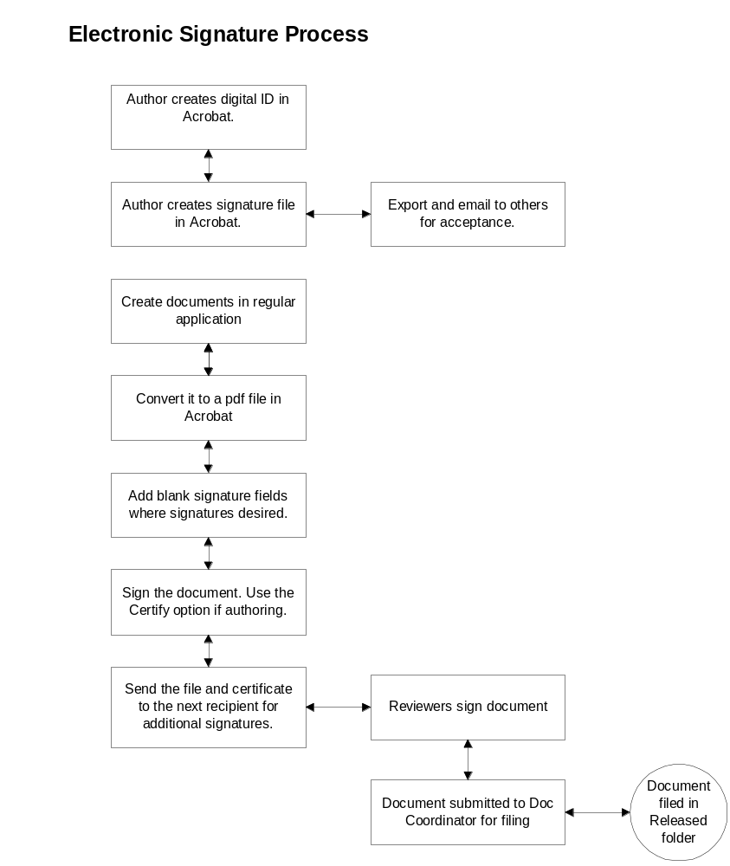

Creating a new digital ID

- From within Adobe Acrobat, select Manage my Digital ID
- Select Advanced>>Manage Digital IDs>>My Digital ID.
- Click Add.
- Click Self-signed Digital ID>>Continue.
- Fill in all fields. Click Create.
- A security warning will appear. Click Yes to install the certificate.
- Export the certificate and email it to the Document Control Coordinator and others who may need to validate your signature. Highlight the certificate in the list and click Export.
- Click the Save the Data to a File radio button, then Next.
- Save the file to your disk. Be sure to remember where you saved it.
- Close the window. You now have a valid certificate, which you will need to share with others. These people will need to import this certificate in order to see signatures and verify that they are valid.

Creating a document to be certified

- Create the document in Word (or other application) and edit until finished. This step includes gathering input from reviewers.
- Include a space for the electronic signature field to appear under the Revision History Table on the cover page.
- Convert the document to a pdf file in Acrobat Standard. (See instructions below.)
- Within Acrobat, click Sign>> Sign this document. An alert appears saying that the document is not certified. Certify it. (Note that if you make any changes after you certify, it invalidates the certification. Do not do this!)
- On the Save as Certified Document dialog, click OK.Select Allowed actions: “Allow form fill-ins.”
- Click Next. Show Certification on document.
- Click Next. Mouse click/drag to show where your certified signature goes.
- Digital ID selection window – select your ID from list. If there is none there, click Add ID, and browse to find one or create a new self-signed one.
- Click OK. Add Reason for signing, and fill in other fields.
- Click Sign and save. You will get a dialog saying that you have successfully signed. Click OK.

Creating a change order (or other record) that will be signed by reviewers.
  - Create the record in Word (or other application) and edit until finished.
  - If the template does not already have one, include a space for your certification and one for each of the reviewer’s signatures.
  - Convert the record to a pdf file in Acrobat Standard. (See instructions below.)
  - Create an electronic signature field for each reviewer.
  - Certify the record in the certification field. When asked to select actions allowed, select “Allow only forms fill-in actions.” (Note that selecting “Disallow any changes” will prevent the next signer from signing the document.)
  - Send the file to the next recipient for his signature.

Converting a document to a .pdf file

- Open the file to be converted in Acrobat.
- Select File>Create pdf from a file>browse to file.
- Click Open and wait until the conversion is completed.
- Alternately, you can use the Adobe menu in Word (if present) to convert the file.

Signing a record
- Open the pdf file.
- Click the Sign button.
- Select Sign this document.
- Click the blank signature field where your signature will be displayed.
- Select a digital ID.
- On the Apply signature to document dialog, fill in all fields, including the reason for signing.
- Click Sign and Save. A dialog will appear saying that you have successfully signed this document.
- Email the document to next reviewer and notify the author that you have signed.

